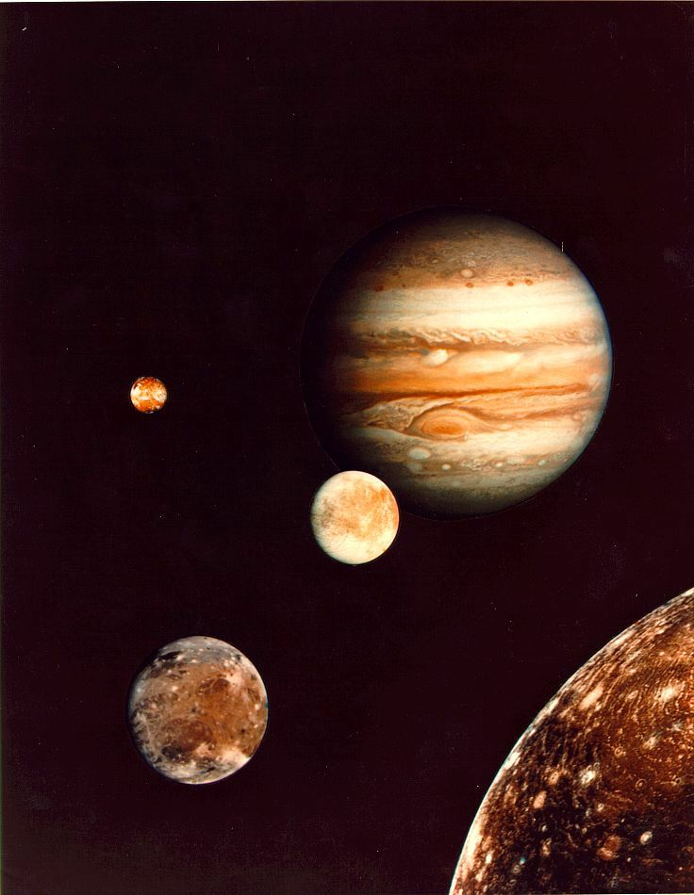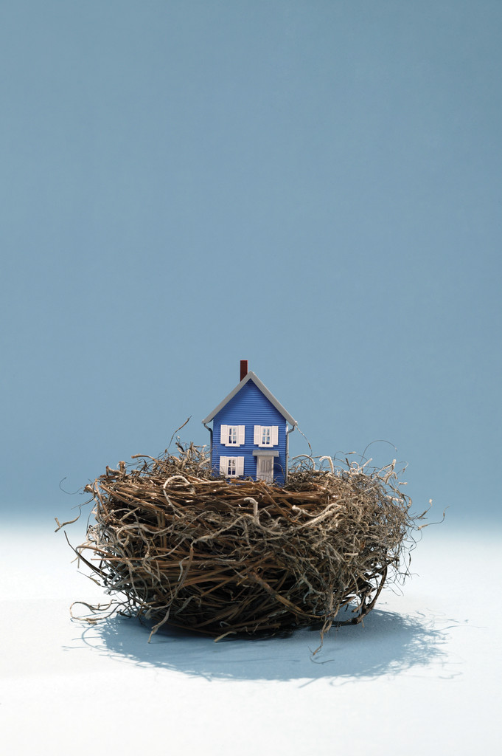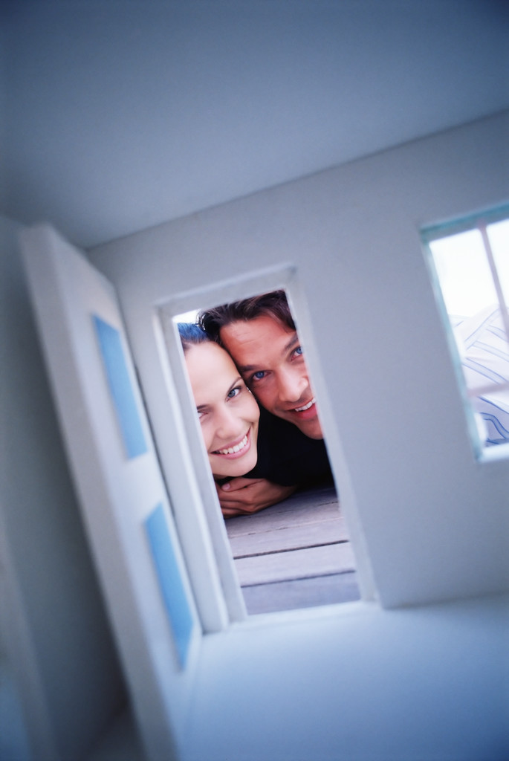

## Citations

# Conditions Suitable for Life?

🙞 🙜

[Street Address]  
[City], [State][Postal Code]

[Web Address]

Dolor Sit Amet

### Mrs. Timson

🙞 🙜

N

p

Jupiter

# Planetary Facts Other Interesting Facts

## Unusual Features: