Timbercrest Middle School - Block Schedule

Monday, Tuesday, Thursday, Friday

2021-2022 School Year – Semester 2

Block Bell Schedule Lunch Assignments
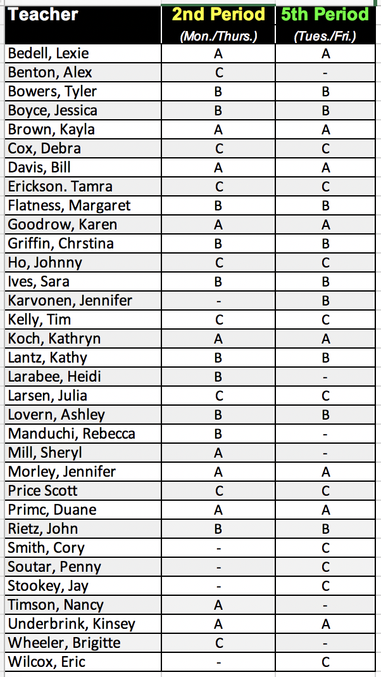
Homeroom | 7:50 – 8:20
Period 1/4 | 8:24 – 10:10
Lunch A | 10:14 – 10:44
Period 2/5 | 10:48 – 12:35
Period 2/5 | 10:14 – 11:13
Lunch B | 11:13 – 11:43
Period 2/5 | 11:47 – 12:35
Period 2/5 | 10:14 – 12:01
Lunch C | 12:05 – 12:35
Period 3/6 | 12:39 – 2:25

›

