Timbercrest Middle School – Early Release Wednesdays
2021-2022 School Year – Semester 2

Bell Schedule Lunch Assignment
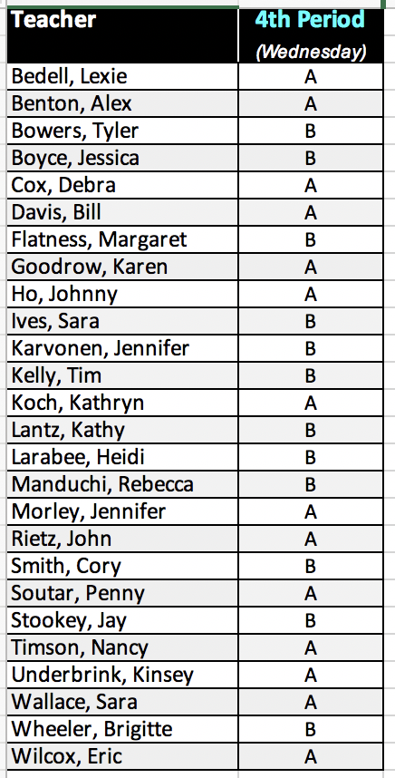

Period 1 | 7:50 – 8:32
Period 2 | 8:36 – 9:18
Period 3 | 9:22 – 10:04
Lunch A | 10:08 – 10:38
Period 4 | 10:42 – 11:24
Period 4 | 10:08 – 10:50
Lunch B | 10:54 – 11:24
Period 5 | 11:28 – 12:10
Period 6 | 12:14 – 12:55

